Brain Tumor Detection Using Deep Learning .

Dr. Arshad Husain Aditi Raj

School of Computing School of Computing

DIT University,Dehradun DIT University,Dehradun

Uttarakhand ,India. Uttarakhand,India.

[arshad.husain@dituniversity.edu.in](mailto:arshad.husain@dituniversity.edu.in) [aditiraj0308@gmail.com](mailto:aditiraj0308@gmail.com)

Sudarshan Kumar Aparna Agarwal

School of Computing School of Computing

DIT University,Dehradun DIT University,Dehradun

Uttarakhand ,India. Uttarakhand,India.

[kumaranshu8092@gmail.com](mailto:kumaranshu8092@gmail.com) [agarwalaparna2001@gmail.com](mailto:agarwalaparna2001@gmail.com)

**ABSTRACT**

Early diagnosis and evaluation of a disease's stage is crucial for successful treatment of any condition. The classification and diagnosis of the disease are crucial for everyone's health. Decision-making, analysis, and measurement are all part of modern diagnosis. Medical decision assistance relies heavily on computers. Because brain cancer is frequently not discovered until it is too late for a prognosis, it is one of the most challenging fatal diseases to treat. Because of its efficiency and safety, MRI is very narrowly focused. The prognosis of brain tumors can be greatly influenced by early diagnosis. The second most common cause of cancer death in children under the age of 15 and the second fastest growing cause of cancer death in people over 65 are brain tumors. Brain tumors can be of two different sorts. The first type of tumor is benign, or non-cancerous, and the second type is malignant, or cancerous. The classification of the tumor is crucial to the development of the treatment strategy and the process of tumor evaluation. Many recent approaches used the four modalities T1, T1c, T2, and FLAIR because each brain imaging modality provides distinct and important details relating to each area of the tumor. While many of them showed promise in their segmentation results on the BRATS 2018 dataset, they all have complex structures that require additional training and testing time. In this paper, we have trained the images on the BR35H Brain tumor dataset available on Kaggle. Convolutional Neural Network architecture was proposed to develop a model with better accuracy and loss-time than other individual research. We also discuss a two-phase training method that enables us to address issues with the imbalance of tumor labeling. In the first phase we will be training the images to detect the tumor and record the accuracy of the model. We will further be working on modifying the model to classify the type of tumor present in the brain.

**I. INTRODUCTION**

In the past few years because of significant advancement in the field of AI, machine learning and deep learning various techniques have been introduced to help doctors diagnose diseases in the early stage easily. Many computer-aided technology uses Medical Image processing techniques to identify such diseases efficiently and reliably. Brain Tumor is also one of such diseases which needs to be diagnosed in the early stage so that the probability of saving the patient’s life increases.The human brain comprises various types of cells and all cells have their own functionality. It receives signals from the body’s sensory organs with the help of the nervous system and gives the information to the muscles what work to do. So if the brain stopped working properly then it will have a very huge impact on the body of a human and can lead to death.In India alone, more than 28,000 people are diagnosed with brain tumors each year, and more than 24,000 of them pass away, according to the International Association of Cancer Registries (IARC). According to a different study, brain tumors are responsible for about 5,250 annual deaths in the United Kingdom.

A brain tumor happens when a tissue begins developing abnormally in the brain. The brain tumor side effects and signs depend largely on its size, area and the rate of development. There are various types of brain tumors some of them are noncancerous while some are cancerous. Majorly there are two types of brain tumors one that begin in the brain known as primary brain tumor and the other one begin in other body parts and spread to the brain known as secondary brain tumors. Primary brain tumors have their name according to the type of cell involved – Gliomas, Meningiomas, Medulloblastomas etc. Gliomas are brain tumors that start in the brain or spinal cord; meningiomas are tumors that start in the membranes that surround the brain and spinal cord; and Medulloblastomas are the most prevalent type of brain tumor in children. It begins in the brain's lower back and spreads throughout the spinal fluid. Brain tumor detection is a very hard and complicated job because tumors generally have different sizes, shapes and locations. Brain tumor diagnosis in the very early stage of a tumor is difficult because it is very hard to accurately measure the size, area and resolution of the brain tumor. Most of the time the reason for brain tumor is unknown but there are many factors which can result in the development of brain tumor such as age, gender, race and ethnicity and many more.

The most well-known and widely used tests for diagnosing brain tumors are magnetic resonance imaging (MRI) and computed tomography (CT) scans. MRI uses radio waves and magnets to view objects inside the human body whereas CT scan is a type of X-ray that involves X-ray machines. An MRI is highly capable at capturing images that helps doctors to determine if there is any abnormal behavior in the tissues. It is a popular non-intrusive imaging technique that provides sensitive tissue contrast. The capacity of MRI to tolerate tissue that is frequently normalized can allow imaging structures of interest in human brain tumors. When it comes to manually segmenting brain MRI images, researchers have recently encountered a challenging and challenging problem . A classification system must be used to appropriately classify tumors and the locations of those tumors within the brain.Depending on the desired tissue type, multiple MRI modalities such as T1, T2, and Fluid Attenuation Recovery (FLAIR) are utilized to identify brain tissue . Due to its high contrast in soft tissue in humans, MRI pictures provide better and more meaningful data than

than other imaging techniques such as CT scan in the field of Medical Detection System. Artificial Intelligence is witnessing a significant amount of growth in minimizing the gap between human capabilities and machine capabilities. One of the domains in artificial intelligence, Computer Vision, is also advancing in this area. The advancement in computer vision has seen rapid growth with the introduction of deep learning. Brain tumors can be recognised by computer vision whether they are present or absent. Additionally, using patient medical data and machine learning technologies, it is now possible to forecast the likelihood of tumor occurrences in the future. Many works have been done in the field of deep learning particularly over one algorithm – Convolutional Neural Networks. A Convolutional Neural Network (CNN) is a deep learning algorithm that takes an image as input and assigns priority to various elements or objects in the image, allowing it to 2 3 distinguish between them. CNN is getting recognition in recent times because of its ability to extract features automatically.

**II. Related Work**

Analyzing and processing MRI brain tumor images is the most challenging and upcoming field. Magnetic resonance imaging (MRI) is an advanced medical imaging technique used to produce high-quality images of the parts contained in the human body and it is a very important process for deciding the correct therapy at the right stage for tumor-infected individuals. Different deep learning methods were used for the various studies to automatically segment and find brain tumors. The study looked into how to forecast survival time using deep features that were derived from pre trained CNNs. It offers more proof that domain-specific fine-tuning will enhance performance. The internet offers a standard dataset. Among the many techniques, convolutional neural network (CNN), DL, and neural network-based techniques are the most popular. In the literature, a number of models that aim to identify precise and effective boundary curves of brain tumors in medical pictures have been used. This section discusses the various techniques and researches don’t in this field. Menze et al. (2014) remarked that over the past few decades, the number of papers on automated brain tumor segmentation has increased dramatically. This finding not only emphasizes the necessity for automatic brain tumor segmentation methods but also demonstrates the ongoing nature of that research. Ramin Ranjbarzadeh [1] used the BRATS 2018 dataset, which consists of Multi-Modal MRI imaging and patient clinical data, containing a variety of heterogeneous histological sub-regions with varying degrees of aggressiveness and prognosis. They used a distance wise approach (DWA) to examine the effect of location of brain tumor in four input modalities and an area-expected approach. Ramdas Vankdothu [...] proposed a new deep learning technique named Recurrent convolutional neural network (RCNN). They used a clustering algorithm for segmentation and a gray level co-occurrence algorithm for feature extraction. The suggested approach could identify and classify pathological and normal tissues with 95.17% precision. S. Meenakshi[...] proposed a Deep Neural Network Architecture to classify MRI images using Kaggle Brain Tumor detection 2020 Dataset. They used seven different combinational architectures for classification problems but the proposed DNN - CFIC model gave comparatively higher accuracy. Their work used the classical ANN for classification because there has been a lot of preprocessing done using different units, such as feature extraction and selections, segmentation using a DNN. In another study, Amin ul Haq [...] utilized the brain tumor data set (BTDS) from the general hospital and Nanfang hospital in China. They employed Transfer Learning (TL) and Data Augmented techniques to improve the predictive accuracy of CNN Model. Sahar Gull [...]used three datasets (BRATS2018, BRATS2019, and BRATS2020) in the proposed model to train and validate it for the most effective identification of brain tumors. They proposed a fully automated methodology for classification and segmentation. The process included preprocessing, skull stripping, segmentation, post processing, and classification. The experimental findings of the suggested methodology demonstrated on these three datasets have achieved the highest batch accuracies of 96.50%, 97.92%, and 98.79%. Samuel Teicher [http://surl.li/gdilt] proposed that new tumor segmentation algorithms that make use of Random Forests and comparable voxel analysis methods have a strong chance of being adopted by MRI installations in the future. With the help of these algorithms, areas of concern on a scan can be swiftly identified and marked for use in diagnosis. Discriminative models frequently employ a traditional machine learning pipeline that relies on manually created features. In these methods, the classifier is trained to distinguish between healthy and unhealthy tissues with the assumption that the input features have a high enough discriminative power because the classifier's behavior is independent of the data' nature. [7] This paper used CNN to detect brain tumors in order to include deep learning into their research, and they contrasted the CNN results with those of the traditional method with the highest accuracy (SVM). The best accuracy achieved with a learning rate of 0.001 was 97.87 %. This literature review reveals that there have been numerous research works published on the segmentation and identification of brain tumors. 3 4 Traditional classifiers were used by some researchers, whereas deep learning techniques were used by others. Using conventional methods, some works produced meaningful results while others did not. But after reviewing these works, we can assert that deep learning outperforms classical classifiers due to their utilization of memory in the network and learning mechanism.

**III. CONVOLUTIONAL NEURAL NETWORK**

The basic idea of a convolutional Neural Network was introduced by Kunihiko Fukushima in the 1980s. CNN is particularly effective at processing and recognizing images. Convolutional layers, pooling layers, and completely connected layers are among the layers that make up this structure. The key part of a CNN is its convolutional layers, where filters are used to extract characteristics like edges, textures, and forms from the input image. The output of the convolutional layers is then sent through pooling layers, which are employed to down-sample the feature maps and retain the most crucial data while lowering the spatial dimensions. One or more fully connected layers are then applied to the output of the pooling layers in order to forecast or categorize the image (a convolution layer or a number of convolution layers remove clear features from input by executing convolution strategies. Each layer may be a set of nonlinear capacities of weighted entireties at assorted orchestrates of spatially close subsets of the past layer's abdicate, which grants the weights to be reused).

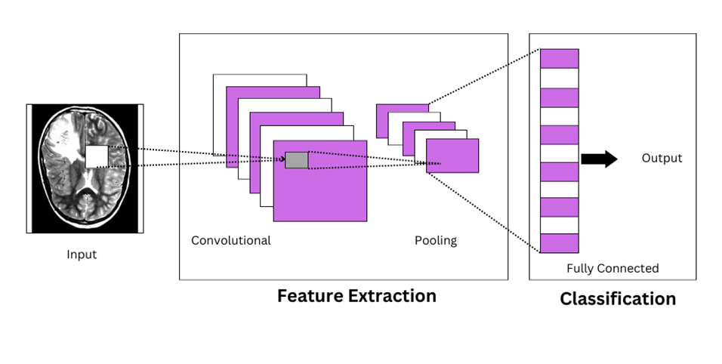 Fig 1-Convolutional Neural Network.

1. ***CNN VS Simple Neural Network***

The architecture of CNNs differs from that of ordinary neural networks. An input is transformed by regular neural networks by passing it through a number of hidden layers. Each layer is composed of a set of neurons, and each layer is entirely connected to every neuron in the layer before it. Moreover, each layer's neurons operate independently of one another and have no connections between them. A final completely linked layer serves as the output layer, which displays the predictions. To complete images, regular neural networks do not scale well.

CNNs are a little bit unique. The layers are first arranged in width, height, and depth, respectively. Moreover, not all of the neurons in a layer are connected to one another.

Transfer Learning is a technique in which we reuse a pre-trained model as the new model on a new task. This pre-trained model already knows how to classify images and also has learned general features from images like edges, shapes etc. In this proposed work 4 pre-trained CNN models have been used – InceptionV3, Xception, DenseNet201, Resnet 152 V2.

Ensemble learning is a technique of combining different machine learning or deep learning algorithms as sometimes one algorithm is not enough to provide the expected result. Different CNNs can learn different features from the images thus providing different results therefore if we combine all the information obtained from different CNN models and make an ensemble we can get better results as shown through this work.

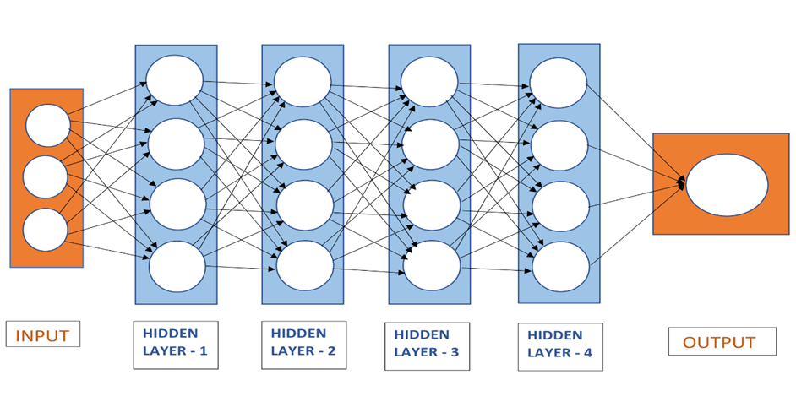

Fig 2:-A Simple Neural Network

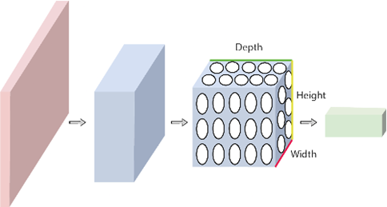

Fig 3:- CNN Background

1. ***Layers used to build CNN.***

A basic CNN consists of a series of layers, each of which uses a differentiable function to transform one volume of activations into another. Primary layer types include:

* **Input layer:** This is the layer where we supply data for our model. A single image or a series of photos will often constitute the CNN input. This layer contains the image's original input, which has the following dimensions: width 32, height 32, and depth 3.
* **Convolutional layer:** this is used to extract the feature from the input dataset. The input images are processed using a collection of teachable filters known as kernels. Smaller matrices, typically 2 by 2 or 3 by 3, or 5 by 5, make up the filters/kernels. It moves across the input image data and calculates the dot product between the kernel weight and the relevant input image patch. Maps with features are what this layer produces.
* **Activation Layer:** By adding an activation function to the output of the preceding layer, activation layers add nonlinearity to the network. it will apply an element-wise activation function to the output of the convolution layer. Some common activation functions are **RELU**: max(0, x), **Tanh**, **Leaky RELU**, etc. The volume remains unchanged hence output volume will have dimensions 32 x 32 x 12.
* **Pooling layer:** This layer is periodically inserted in the CNNs and its main function is to reduce the size of volume which makes the computation fast, reduces memory and also prevents overfitting. Two common types of pooling layers are **max pooling** and **average pooling**. If we use a max pool with 2 x 2 filters and stride 2, the resultant volume will be of dimension 16x16x12.
* **Flattening layer:** After the convolution and pooling layers, the resulting feature maps are flattened into a one-dimensional vector so they may be sent into a fully connected layer for categorization or regression.
* **Fully Connected Layers:** It computes the final classification or regression task using the input from the preceding layer.
* **Output Layer:** For classification tasks, the output from the fully connected layers is then fed into a logistic function like sigmoid or softmax, which transforms the output of each class into the probability score of each class.

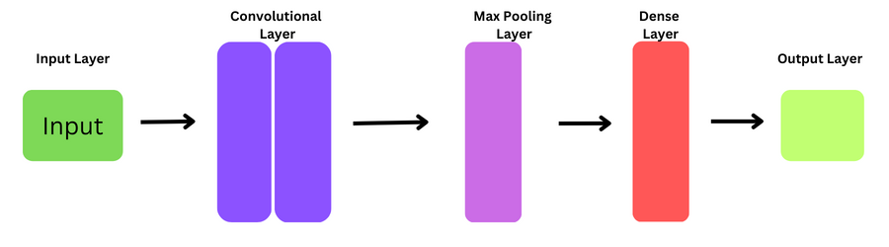

Fig 4:- CNN Layers

1. ***CNN Architecture:***

Convolutional Neural Network consists of multiple layers like the input layer, Convolutional layer, Pooling layer, and fully connected layers.

The Convolutional layer applies filters to the input image to extract features, the Pooling layer down samples the image to minimize computation, and the fully connected layer provides the final prediction. Via gradient descent and backpropagation, the network learns the best filters.

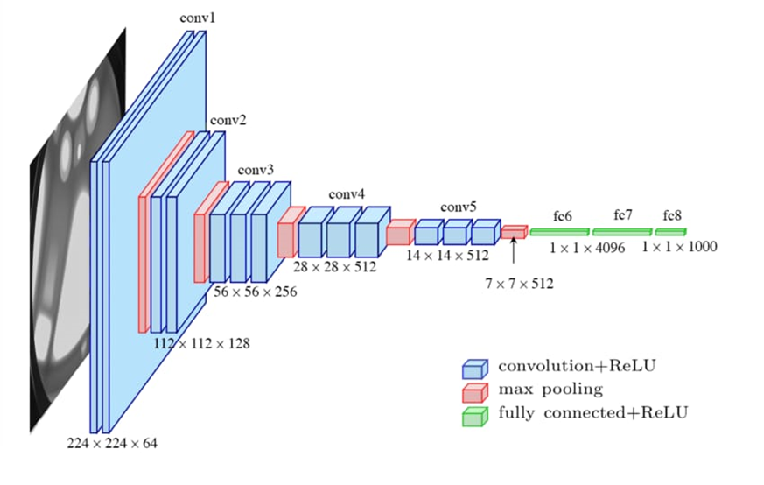

Fig 5:- CNN Architecture

**IV: OUR CONVOLUTIONAL NEURAL NETWORK (CNN) APPROACH**

The objective of this work is to detect and classify brain tumors. In order to achieve this, we are going to utilize Convolution Neural Networks (CNNs) to form an outfit of deep learning highlights. Models will examine pictures one at a time and recognize the symbol sort. The MRI-based brain tumor pictures will be utilized for preparing and testing reasons. Finally, we will plan a GUI (graphical client interface) website using React and FastApi. Often, brain tumors are mass-like developments of irregular cells within the brain. Numerous diverse sorts of brain tumors exist. A few brain tumors are noncancerous (kind), and a few brain tumors are cancerous(malignant).

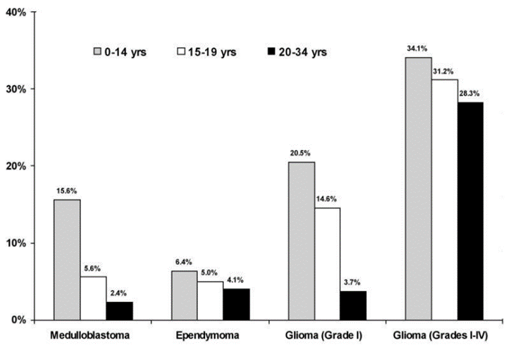

Fig 6:– Distribution of brain tumor types by age

Dissemination of tumors and tumor area by age is an interesting angle of a brain tumor in the study of disease transmission. Certain tumor sorts, such as. medulloblastoma, ependymoma, and pilocytic astrocytoma show less increase as they age as shown in the figure above. It is imperative to note that in spite of the huge contrasts in extent between ependymomas and medulloblastomas, spinal ependymomas are among the foremost common among the exceptionally youthful, the pre-adult, and within grown-up, respectively.

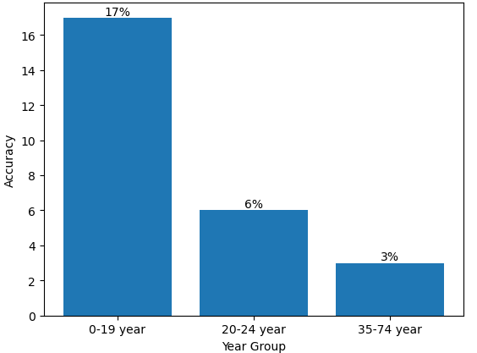

Fig 7:-Proportion of brain tumors involving the cerebellum by age group

As we can see from the above graph, mostly brain tumors occur in children or teenagers so we need to classify them as soon as possible so that treatment can be done on them and we can stop the further growth of the tumor. There are an assessed 20,500 fundamental brain tumors analyzed each year inside the US: 3750 cases happen in individuals age.

***1.******Architecture of the Model***

The convolutional layer serves as the foundation of a CNN architecture. It has a number of filters (or kernels), whose settings must be learned over the course of training. Typically, the filters' size is smaller than the original image. Each filter produces an activation map after it convolves with the image. In order to extract features from the input image, a convolution layer alters it. This transformation involves convolving the image with a kernel. (or filter). A hierarchy of features can be created by stacking various layers on top of one another. It is possible to think of each layer as extracting features from the layer above it and adding them to the hierarchy to which it is connected. A single convolutional layer generates a number of output planes or feature maps from a stack of input planes as its input. The Convolutional layer applies filters to the input image to extract features, the Pooling layer down samples the image to minimize computation, and the fully connected layer provides the final prediction. Via gradient descent and backpropagation, the network learns the best filters.

***2.******Functional description of the model***

In this study we have first imported our dataset and library.We read the images and converted them from BGR to RGB. The images present in the dataset were of all different sizes so we converted them to (224,224,1). We have used 3000 images in total. We used a Numpy array to convert the image dataset to an array. We divided our dataset into two categories: trained and tested in a ratio of 70 and 30 percent, where 70% of the images were kept for training and 30% was kept for testing. We normalized the dataset and imported a sequential model (conv2D for generating different layers.)

In this section we will talk about three main topics regarding this project which are :

* Image pre-processing.
* Feature extraction using an ensemble of Convolutional Neural Networks (CNNs)
* Machine learning classifier for brain tumor classification.

**2.1**  **Image pre-processing**

The images present in the dataset are all of the different sizes so we have converted them to (224, 244) images size after this we applied Gaussian Blur on the images for the removal of noise from the images and converted all the images to RGB images. We have also done Image data augmentation.

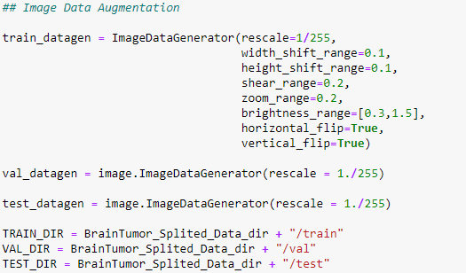

Fig 8:-Image Data Augmentation

**2.2**  **Feature extraction using an ensemble of CNNs**

Convolutional Neural Networks have gained a significant amount of attention in the last few years as they can automatically extract features and outperforms any other feature extraction technique when the amount of data is huge. A CNN’s convolutional layer applies convolutional channels to the input in order to compute the surrender of neurons that are related to regions inside the input.

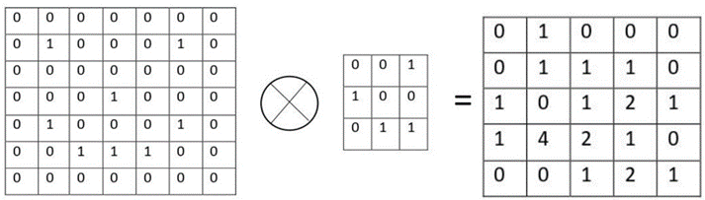

Fig 9:- CNN Feature Extraction

CNN is by and expansive comprised. of mainly three units that are convolutional layers that are being used to extract features from the data then comes the max-pooling or globalaveragepooling2d layer which is being used for dimensionality reduction and then comes the fully connected artificial neural network layer which then uses the extracted features and acts as a classifier to classify the images.

In this work, we have taken a CNN based approach in which the convolutional layers are being used to extract features from the images and then the features obtained are then passed onto a fully connected neural network that classifies the class of the image. The pre-trained CNN models utilized in this wander are InceptionV3, Resnet152V2, Densenet201, and Xception.

**2.3. Fully Connected Neural Network as a classifier:**

The features extracted from the CNNs are then fed into the fully connected neural network but before that, we have applied the GlobalAveragePooling2D layer before the classification layers. In the classification hidden layer, we have applied the relu activation function and softmax activation in the output layer. The loss function used in this is Adam and the learning rate used is 0.001.

**V. PROPOSED METHODOLOGY**

***1:*** ***Proposed 9-layer CNN architecture for the Brain Tumor detection***

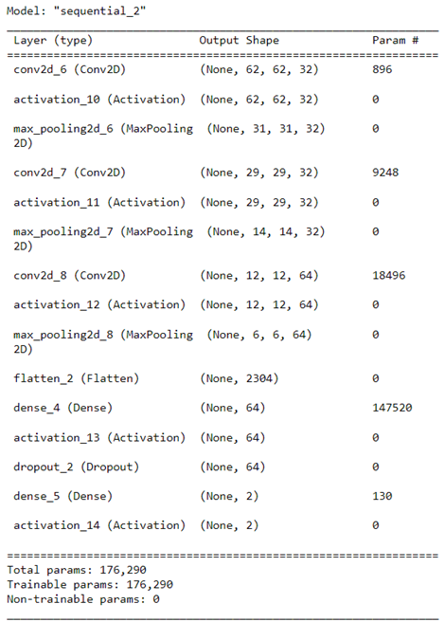

**Table – 1** Modified parameter in the convolution network to classify the 2 categories.

Figure shows the proposed architecture of the 2D CNN. A set of 3000 images were used in this study of which 90% (2700) were used for the training data and 10% (300) used for the testing data. The proposed network had several layers including convolutional which possessed two convolutional layers with 32 filters and one convolutional layer with 64 filters. All the three convolutional layers with 32,32 and 64 filters respectively have 3*3 kernel functions.

The convolutional network has a hierarchical structure. This network creates links between convolutional layers, alternate pooling layers and fully connected layers. Figure shows that the network has 3 convolutional 2D layers and 3 pooling layers. The final pooling layer with 2D output is changed to a 1D layer by flatten layer so that it can be sent to the fully connected layer. To classify the data into categories by SoftMax activation function, a total of 64 fully connected layers and 5 fully connected layers were used. In this process, to prevent overfitting a dropout layer with a rate of 0.5 was also used following the fully connected layer.

For the Activation function, the ReLU function was used in all the layers apart from the last fully connected layer in which we have used the SoftMax activation function. Adam was used as the optimizer. After 20 epochs, the training process was confirmed with 150 iterations. The batch size was 16, each epoch lasted about 6s. The features extracted from the convolutional layer to Ufc = 64 hidden layers. The number of weights (Wconv) depended on the output size of the prior convolutional layer(y1*y2) , the number of filters(k) , and the number of hidden layers in fully connected layers. Thus, the convolutional layers weight was determined by: Wconv = y1*y2*k* Ufc = 6*6*64*64 = 147456 where the number of existing parameters to the first fully connected layer equals 147456 + 64(bias) = 147520.

A summary of learning parameters for the proposed network can be seen in table 1, the value of all parameters used to determine the 4 categories of this network are calculated by summing up the values cited in the params columns in table 1. The consequent value is 176,290, where all the parameters are trainable.

***2:*** ***Proposed Ensemble deep learning method for the Brain Tumor detection***

In this model we have used Ensembled model, in this we have used 4 pre-trained models that are InceptionV3, ResNet152V2, Xception, DensNet. We have trained on the google colab with CPU 13.5/15.7 GB of DDR5 RAM and GPU 10.9/15.9 GB on Tesla K80.

**InceptionV3:**

Compared to the inception V1 and V2 models, the inception V3 model has 42 layers, which is a little more. However, this model's effectiveness is absolutely remarkable. We'll get to it shortly, but let's first take a closer look at the parts that make up the Inception V3 model.

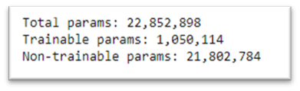

Fig 10:-Inception V3 Model Summary

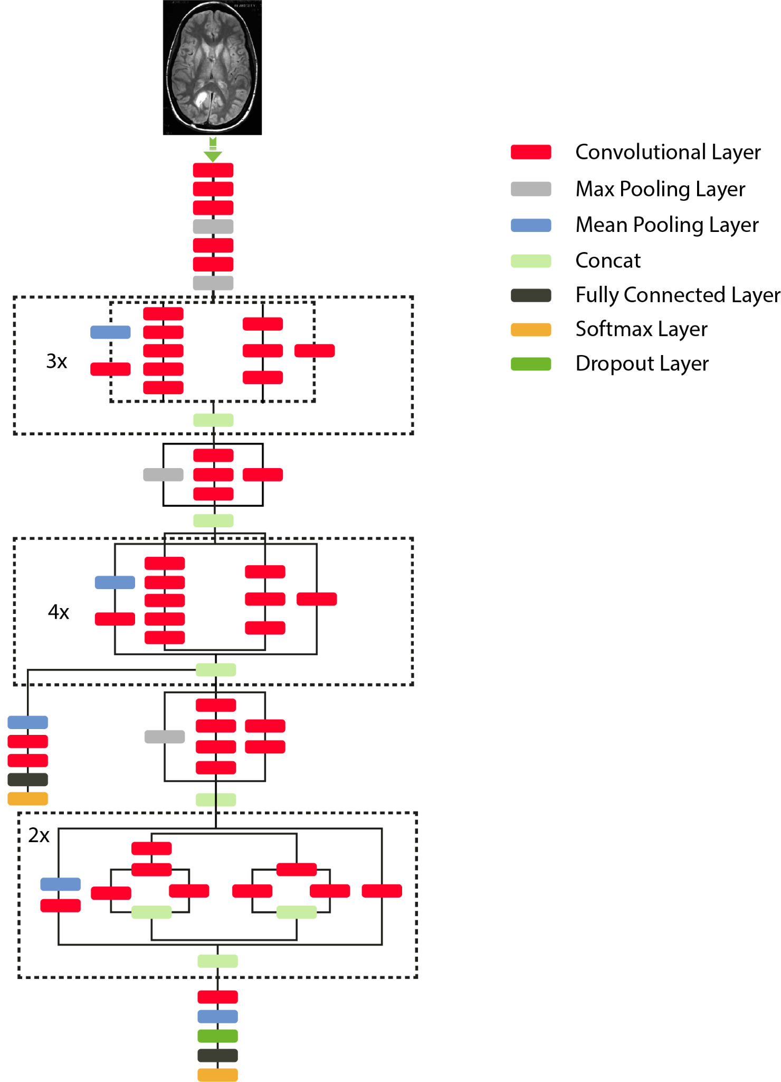

* **InceptionV3 architecture**

In this we have passed the pre-processed images and then we trained the model with a given dataset or pre-processed images after which it has given 98.04%,98.22%, 98.21% training, testing and validation accuracy respectively. We trained the model for 100 epochs with a batch size of 32 and each epoch had 65 iterations and each iteration took around 33s.

**ResNet152V2:**

As seen in the architecture of ResNet152V2, ResNet152V2 is employed as a feature extraction model as opposed to the VGG19-CNN model. Because it was pre-trained , the model has beginning weights, which can help it achieve acceptable accuracy more quickly than a conventional CNN. The ResNet152V2 model is the foundation of the model architecture, which also includes a reshape layer, flatten layer, dense layer with 128 neurons, dropout layer, and dense layer with Softmax activation function to classify the image into the appropriate category. Table 3 provides specifics on the architecture. The ResNet152V2 has a total of 59,381,762 parameters, which are divided into two categories: trainable parameters and non-trainable parameters, which have respective values of 1,050,114 and 58,331,648.

As a pre-trained model, ResNet152V2 provides various benefits, including a faster learning curve and a quicker convergence to high accuracy. It can therefore be added before deep learning models to create models that are effective and trustworthy, leading to improved accuracy.

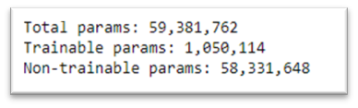Fig 11:-ResNet152V2 Model Summary

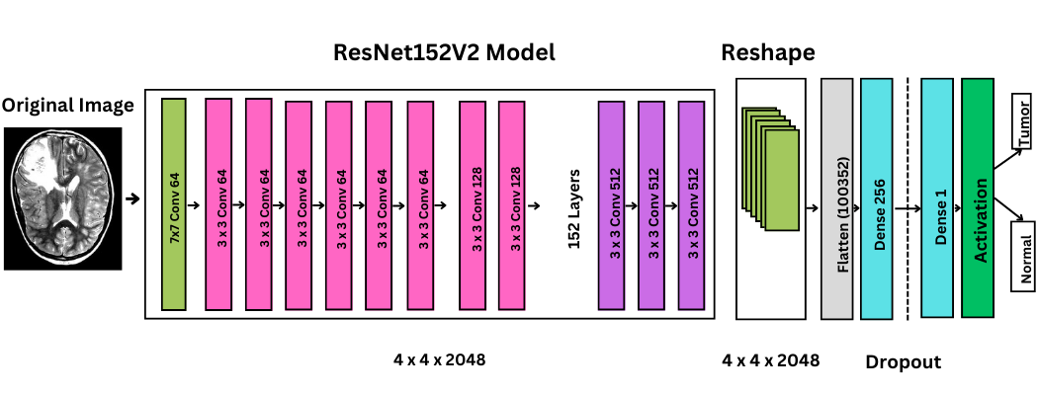

* **ResNet152V2 architecture**

In this we have passed the pre-processed images and then we trained the model with a given dataset or pre-processed images after which it has given 99.57%,98.22%, 98.66% training, testing and validation accuracy respectively. We trained the model for 100 epochs with batch size of 32 and each epoch had 65 iterations and each iteration took around 47s.

**Xception:**

The core principles of Inception are stretched to their absolute extent by Xception, which stands for "extreme inception." In Inception, the initial input was compressed using 1x1 convolutions, and we used various sorts of filters on each depth space from each of those input spaces. Just the opposite occurs with Xception. Instead, it applies the filters to every depth map separately before compressing the input space all at once with 1X1 convolution. This process is nearly equivalent to a depthwise separable convolution, a technique that was first applied to the building of neural networks in 2014. Between Inception and Xception, there is yet another distinction. if a non-linearity exists or not after the initial procedure. In the Inception model, a ReLU non-linearity follows both processes, whereas Xception doesn't add any non-linearity.

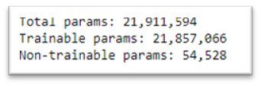 Fig 12:-Xception Model Summary

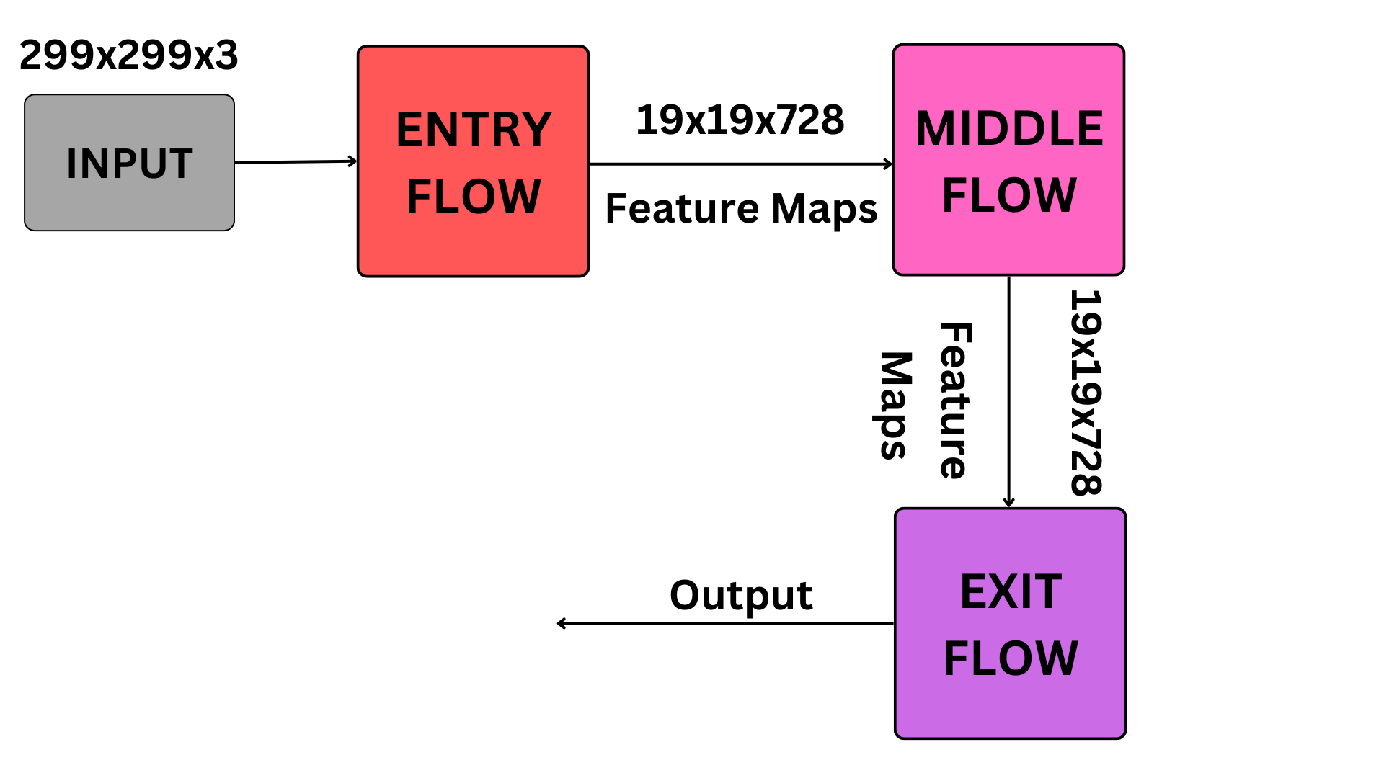

* **Xception architecture**

In this we have passed the pre-processed images and then we trained the model with a given dataset or pre-processed images after which it has given 98.07%,97.33%, 97.77% training, testing and validation accuracy respectively. We trained the model for 90 epochs with batch size of 32 and each epoch had 65 iterations and each iteration took around 90s.

**DenseNet:**

In traditional feed-forward CNN each convolutional layer except the first one receives the output of the previous convolutional layer and produces an output feature map that is then passed on to the next convolutional layer which as they gets deeper the ‘vanishing gradient’ problem arises which increases from the input to the output layer increases, it can cause certain information to ‘vanish’ or get lost which reduces the effectiveness of the model to train.

DenseNets address this issue by adjusting the typical CNN architecture and streamlining the connectivity structure across layers. The term "Densely Connected Convolutional Network" refers to an architecture in which every layer is directly connected to every other layer.

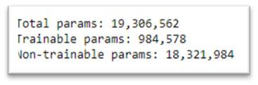

Fig 13:-DenseNet Model Summary

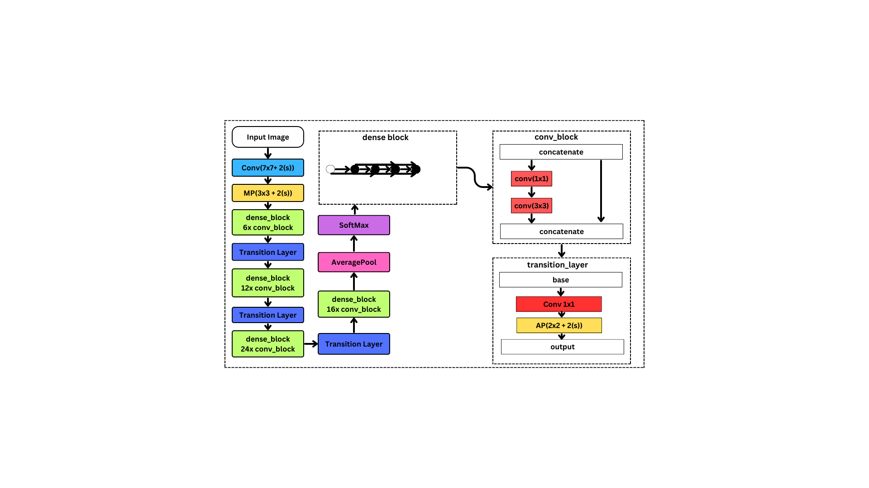

* **DenseNet architecture**

In this we have passed the pre-processed images and then we trained the model with a given dataset or pre-processed images after which it has given 99.27%,98.66%, 98.88% training, testing and validation accuracy respectively. We trained the model for 90 epochs with batch size of 32 and each epoch had 65 iterations and each iteration took around 49s.

**VI. EXPERIMENTS AND RESULTS**

Our dataset contains Tumor and non – Tumor MRI images and collected from multiple online sources like Kaggle, git repositories and Radiopaedia which contains real cases of patients. And the one dataset we used is Br35H which contains 1500 non – Tumor images and 1500 Tumor images which we further divided into Training Dataset, Test Dataset and Validation Dataset 70% 15%, 15% respectively.

| Brain Tumor MRI Images | Normal Brain MRI Images |
| --- | --- |
|  |  |
|  |  |
|  |  |
|  |  |

Table 2:- Brain Tumor MRI Images vs Normal Brain MRI Images

In this work, efficient automatic brain Tumor detection is performed by using convolution neural networks. Simulation is performed by using python language. The accuracy is calculated and compared with all other state of the arts Machine Learning Methods. The train Accuracy, validation accuracy, validation loss and training loss are calculated to find the efficiency of proposed brain Tumor classification scheme. In the existing techniques, the SVM based classification is performed for brain Tumor detection. It needs feature extraction output. Based on feature value, the classification output is generated, and accuracy is calculated. The computation time is high, and accuracy is low in SVM based Tumor and non-Tumor detection as shown in the image below.

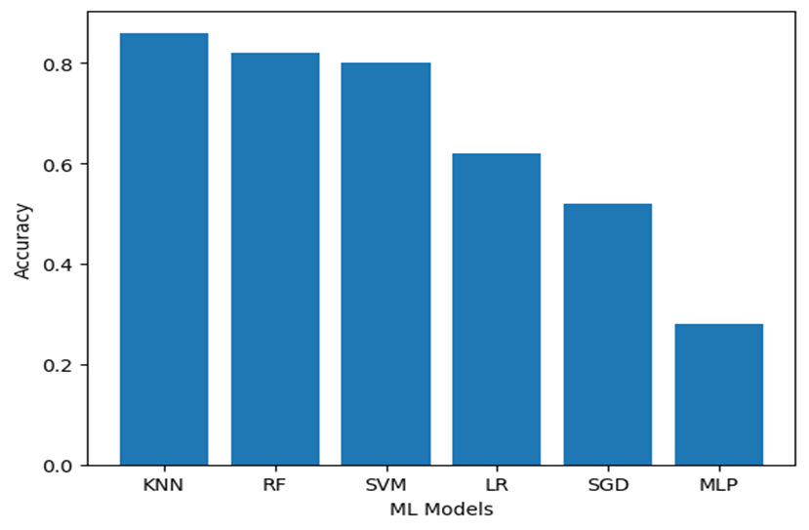

Fig 14:-Comparison Graph

In our work we have trained two models, one with 9-layer architecture and another one is using the Ensemble Model in which we trained 4 pre-build architectures and fed our data to them. Using transfer learning we have achieved the accuracy of 98.04 training accuracy,98.21 % validation accuracy for InceptionV3 and 99.57% training accuracy, 98.66% validation accuracy for Resnet152V2 and 98.07% training accuracy, 97.768% validation accuracy for Xception and 99.27% training accuracy, 98.88% validation accuracy for DenseNet models of which we made ensemble model which have given us the highest accuracy result as 98.66% training, 99.55% validation and 100.00% testing accuracy.

The accuracy we achieved by our proposed 9-layer architecture is 99.75% training accuracy and 98.50% validation accuracy as mentioned in the Table no 3 -

| **Model Name** | **Training Accuracy** | **Testing Accuracy** | **Validation Accuracy** |
| --- | --- | --- | --- |
| InceptionV3 | 98.04% | 98.22% | 98.21% |
| Resnet152V2 | 99.57% | 98.22% | 98.66% |
| Xception | 98.07% | 97.33% | 97.77% |
| DenseNet | 99.27% | 98.66% | 98.88% |
| Ensemble | 98.66% | 100% | 99.55% |
| 9-Layer CNN | 99.75% | 98.40% | 98.50% |

Table 3:-Training,Testing and Validation Accuracy of various models

**Our proposed Ensemble model** accuracy and loss chart in which we have trained on the google colab with CPU 13.5/15.7 GB of DDR5 RAM and GPU 10.9/15.9 GB on Tesla K80 In this we have trained all the 4 pre trained models with our data which are:

1. InceptionV3 which we ran for 100 epochs with batch size of 32 and each epoch had 65 iteration and each iteration took around 33s with loss: 0.0561 - accuracy: 0.9826 - val_loss: 0.0829 - val_accuracy: 0.9777.

2. Resnet152V2 which we ran for 100 epochs with batch size of 32 and each epochs had 65 iterations and each iteration took around 47s with loss: 0.0381 - accuracy: 0.9874 - val_loss: 0.0696 - val_accuracy: 0.9888.

3. Xceptions which we ran for 90 epochs with batch size of 32 and each epoch had 65 iterations and each iteration took around 90s with loss: 0.0393 - accuracy: 0.9860 - val_loss: 0.1263 - val_accuracy: 0.9754.

4. DenseNet which we ran for 90 epochs with batch size of 32 and each epochs had 65 iterations and each iteration took around 49s with loss: 0.0285 - accuracy: 0.9898 - val_loss: 0.0673 - val_accuracy: 0.9866.

After training all these models we assembled them and took the best of all accuracy from which we got 98.66% training accuracy, 100.0% testing accuracy and 99.55% validation accuracy. 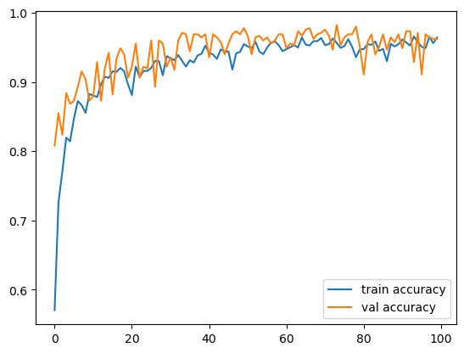 Fig 15:-Inception accuracy

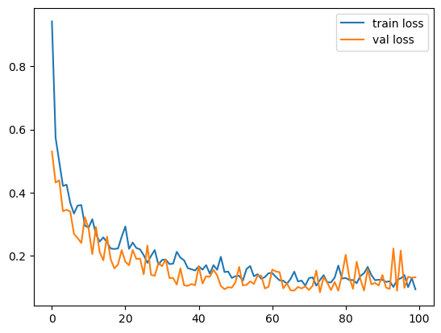

Fig 16:-Inception Loss

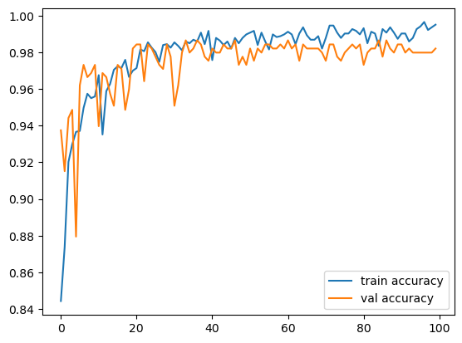

Fig 17:-Resnet Accuracy

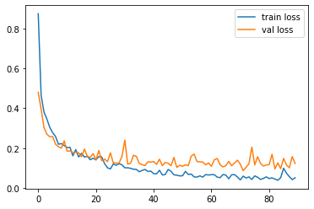

Fig 18:-Resnet Loss

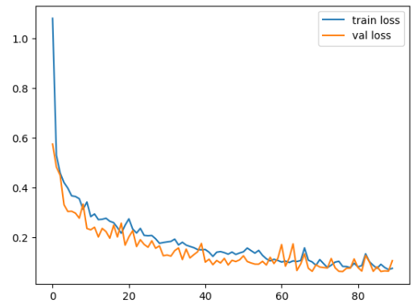

Fig 19:- Xception loss

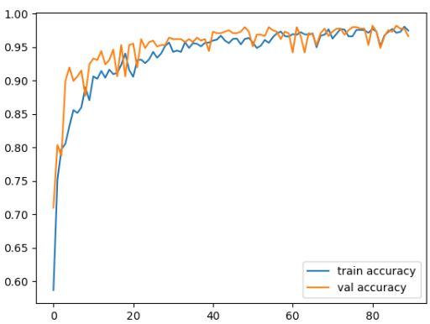

Fig 20:-Xception Accuracy

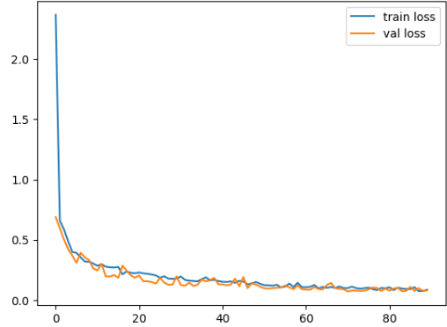

Fig:- 21 DenseNet Loss

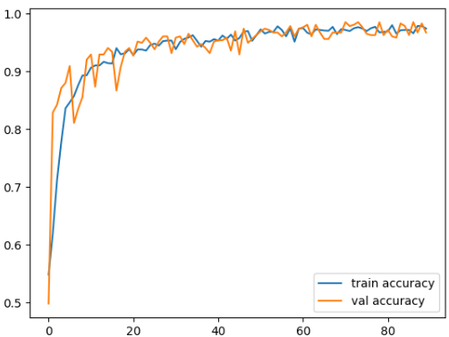

Fig 22:-DenseNet accuracy

**Our Proposed 9 Layer model** accuracy and loss chart is shown below which has the accuracy of 98.33% in which we have several layers including convolutional which possessed two convolutional layers with 32 filters and one convolutional layer with 64 filters. All the three convolutional layers with 32,32 and 64 filters respectively have 3*3 kernel functions.

The convolutional network has a hierarchical structure. This network creates links between convolutional layers, alternate pooling layers and fully connected layers. Figure shows that the network has 3 convolutional 2D layers and 3 pooling layers. The final pooling layer with 2D output is changed to a 1D layer by flatten layer so that it can be sent to the fully connected layer. To classify the data into categories by SoftMax activation function, a total of 64 fully connected layers and 5 fully connected layers were used. In this process, to prevent overfitting a dropout layer with a rate of 0.5 was also used following the fully connected layer which we trained for 20 epochs with batch size of 16 and each epoch were having 150 iterations with loss: 0.0096 - accuracy: 0.9975 - val_loss: 0.1257 - val_accuracy: 0.9850, which we trained on local CPU with 5.9/7.9GB space of DDR5 RAM and GPU(Intel UHD Graphics 630) and used Jupyter Notebook for the code writing and model training using python language.

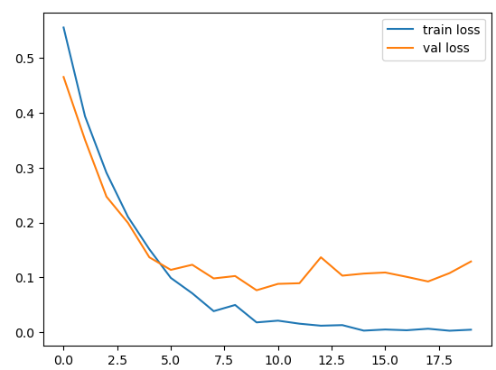

Fig 23:-9-Layer CNN Loss

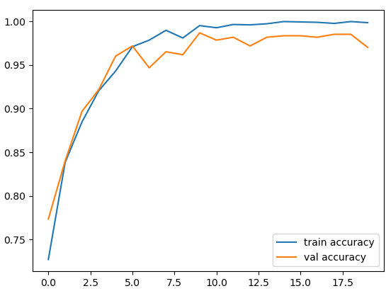

Fig 24:-9-Layer CNN Accuracy

**VII. CONCLUSION**

In this cutting-edge world, full of incredible advances, brain tumors could be an exceptionally unsafe malady additionally exceptionally common among individuals. In 2018, brain tumors were found as the 10th most common kind of tumor among Indians. The All-Inclusive Alliance of Cancer Registries (IARC) points out that there are over 28,000 cases of brain tumors nitty gritty in India each year and more than 24,000 individuals supposedly pass on due to brain tumors each year. This demonstration aims to classify brain tumors to drop the passing rate in India due to brain tumors. This framework will tell the individuals whether they have a brain tumor or not.

Our project consisted of three main steps which are image preprocessing, feature extraction, and then using a classifier for brain tumor classification.

* The images present in the dataset are all of different sizes so we have converted them to (224, 244) images size. After this we applied Gaussian Blur on the images to remove noise from the images and converted all the images to RGB images.
* We have taken a CNN based approach in which the convolutional layers are being used to extract features from the images and then the features obtained are then passed onto a fully connected neural network that classifies the class of the image. The pre-trained CNN models utilized in this wander are InceptionV3, Resnet152V2, Densenet201, and Xception.
* The features extracted from the CNNs are then fed into the fully connected neural network but before that, we have applied the GlobalAveragePooling2D layer before the classification layers. In the classification hidden layer, we have applied the RELU activation function and softmax activation in the output layer. The loss function used in this is Adam and the learning rate used is 0.001.

We trained our model on a lot of pre-trained models like DenseNet, Exception, and Inception, and then used an Ensemble to improve our accuracy. We achieved 100% testing accuracy, 98.66% training accuracy, and 99.55% validation accuracy respectively.

**VIII. REFERENCES**

[1] Malika Bendechache , Maryam Naseri

**Brain tumor segmentation based on deep learning and an attention mechanism using MRI multi-modalities brain images.**

(2021),<https://www.nature.com/articles/s41598-021-90428-8#Bib1>

[2] Ramdas Vankdothu , Mohd Abdul Hameed

**Brain tumor MRI images identification and classification based on the recurrent convolutional neural network**

(2022),<https://www.sciencedirect.com/science/article/pii/S2665917422000460#bib49>

[3] Ketan Kotecha , S. Meenakshi

**MRI Brain Tumor Image Classification Using a Combined Feature and Image – Based Classifier**

(2022),<https://www.frontiersin.org/articles/10.3389/fpsyg.2022.848784/full>

[4] Amin ul Haq , Jian Ping Li

**Deep Learning Approach for classification of Brain Tumors using MRI data in the Iot Healthcare department.**

(2022),<https://rb.gy/ii6sn>

[5] Shahzad Akbar, Sahar Gull

**Automated Detection of Brain Tumor through Magnetic Resonance Images Using Convolutional Neural Network**

(2021),<https://www.ncbi.nlm.nih.gov/pmc/articles/PMC8668304/>

[6] Samuel Teicher , Alexander Martinez

**Diagnosing and Segmenting Brain Tumors and Phenotypes using MRI Scans**

(2014),<http://surl.li/gdilt>

[7] Tonmoy Hussain, Mohsena Ashraf

**Brain Tumor Detection using Convolutional Network**

(2019),<http://surl.li/gdilt>

[8].  [N. Varuna Shree](https://pubmed.ncbi.nlm.nih.gov/?term=Varuna%20Shree%20N%5BAuthor%5D) and T. N. R. Kumar

**Identification and classification of brain tumor MRI images with feature extraction using DWT and probabilistic neural network**

(2018),<https://www.ncbi.nlm.nih.gov/pmc/articles/PMC5893499/>

[9]. Mohammad Havaei , Axel Dav

**Brain Tumor Segmentation with Deep Neural Networks**

(2017),<https://www.sciencedirect.com/science/article/abs/pii/S1361841516300330>

[10]. Md. Saikat Islam Khan, Anichur Rahman

**Accurate brain tumor detection using deep convolutional neural network**

(2022),<https://www.ncbi.nlm.nih.gov/pmc/articles/PMC9468505/#b0015>

[11]. Tustison, Nicholas J

**Advanced Normalization Tools**

(2009),<https://www.insight-journal.org/browse/publication/681>

[12]. Narmada M. Balasooriya , Ruwan D. Nawarathna

**A sophisticated convolutional neural network model for brain tumor classification**

(2017), <https://ieeexplore.ieee.org/abstract/document/8300364>

# [13]. Dinggang Shen, Guorong Wu, Heung -1l Suk

# Deep Learning in Medical Image Analysis

(2017),<https://www.annualreviews.org/doi/abs/10.1146/annurev-bioeng-071516-044442>

[14]. Narmada M. Balasooriya, Ruwan D. Nawarathna

**A sophisticated convolutional neural network model for brain tumor classification**

(2017),<https://ieeexplore.ieee.org/abstract/document/8300364>

# [15].**CDHO Advisory Brain Tumors**

# (2019),<https://www.cdho.org/Advisories/CDHO_Advisory_Brain_Tumours.pdf>

# [16]. Shrutika Santosh Hukkar

# **Implementation Of image processing for detection of brain tumors**

# (2017),<https://www.researchgate.net/publication/322560339_Implementation_of_image_processing_for_detection_of_brain_tumors>

# [17]. [Milica M. Badža](https://sciprofiles.com/profile/951379) ,[Marko Č. Barjaktarović](https://sciprofiles.com/profile/340061)

# **Classification of Brain Tumors from MRI Images Using a Convolutional Neural Network**

# (2020),<https://www.mdpi.com/2076-3417/10/6/1999>

# [18]. Hassan Ali Khan1 , Wu Jue1

# **Brain Tumor Classification in MRI image using Convolutional Neural Network**

# (2020),<http://www.aimspress.com/fileOther/PDF/MBE/mbe-17-05-328.pdf>